INSERTION OF A NODE INSIDE YOUR DOM

//more elements into your webpage aka html

**ONE METHOD OF DOING THIS**



# Insertion Methods

eg

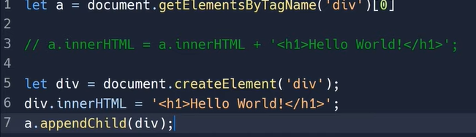

Some more examples

## elem.appendChild(“newlyCreatedDiv”);

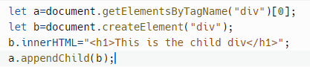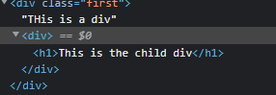

## ALL METHODS

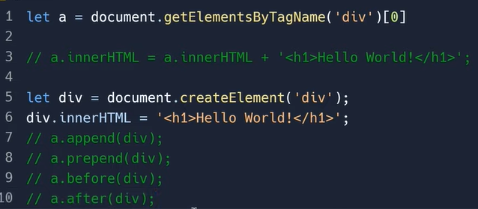

## INITIAL HTML

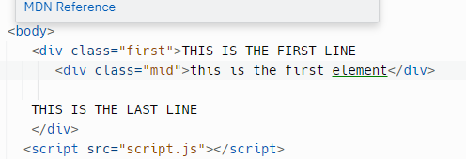

## appendChlid

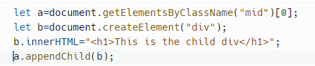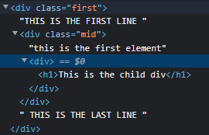

## Append

Similar to appendChild

//and the new element is places before the ending of the parent element

## Prepend

a.prepend(b)

//new div is placed as a chlid but at the start of the parent div

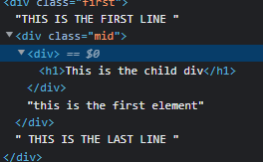

## Remove();



//use nodeName.remove(); to remove that elemnt using js

## Before

a.before(b)

//placed as a sibling before the node

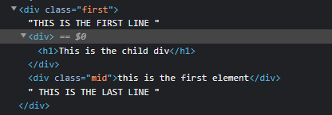

## After

a.after(b);

//placed as a sibling after the node

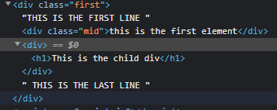

## replaceWith

a.replaceWith(b);//replaces that node with the new node

